**Animesh Parab T2-T21 88**

**ASSIGNMENT-4**

**AIM:** To study AWS CodePipeline and deploy web application using Code

**LO MAPPED: LO1 , LO2**

**THEORY:**

Amazon Simple Storage Service (Amazon S3) is an object storage service offering industry-leading scalability, data availability, security, and performance. Customers of all sizes and industries can store and protect any amount of data for virtually any use case, such as data lakes, cloud-native applications, and mobile apps. With cost-effective storage classes and easy-to-use management features, you can optimize costs, organize data, and configure fine-tuned access controls to meet specific business, organizational, and compliance requirements.

**STEPS:**

1. **Log in as IAM User. Search for S3 in console**

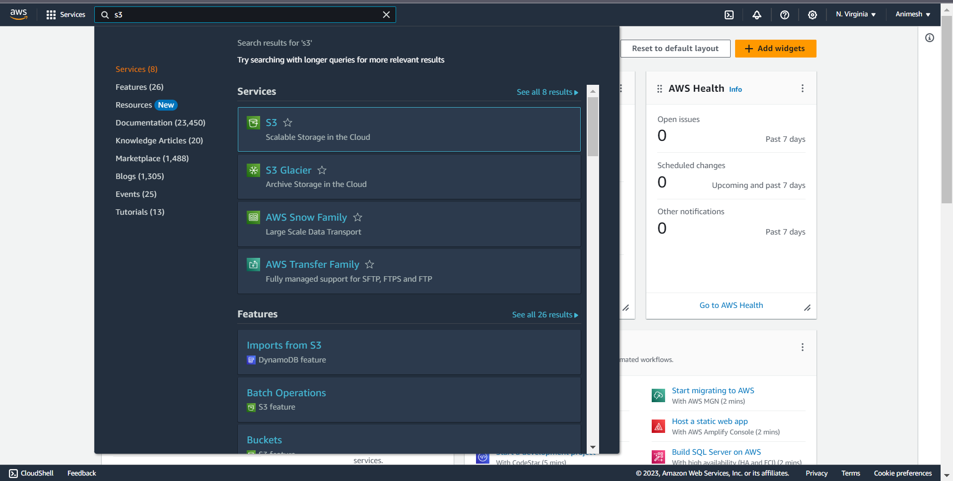

1. **Create a new bucket by clicking Create Bucket Button**

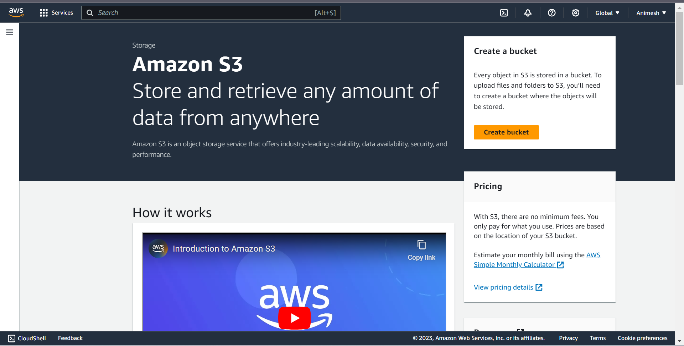

**3. Give the bucket a name and click on Create Bucket to make a new bucket**

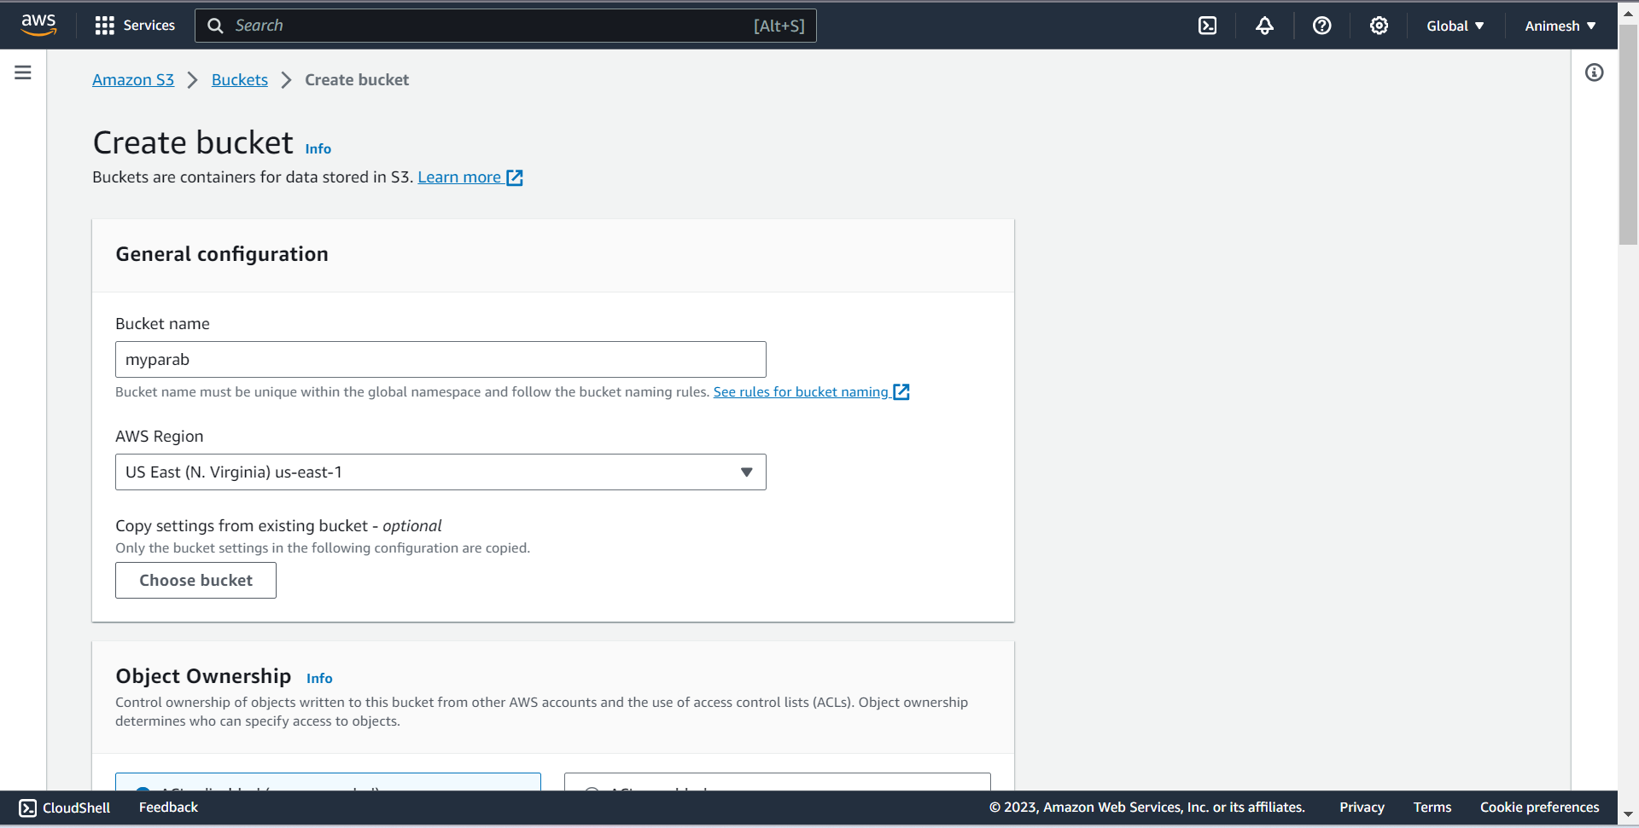

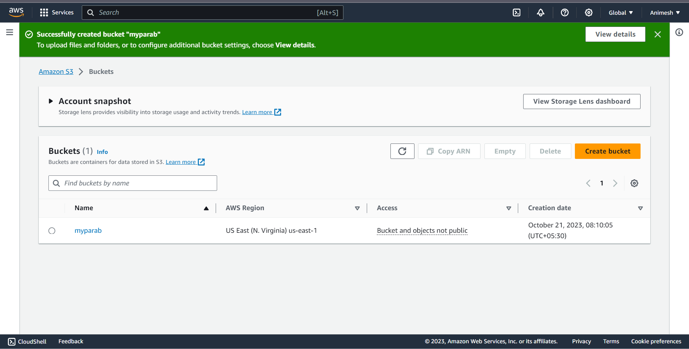

1. **Click on Upload button to add files and folders of your projects.**

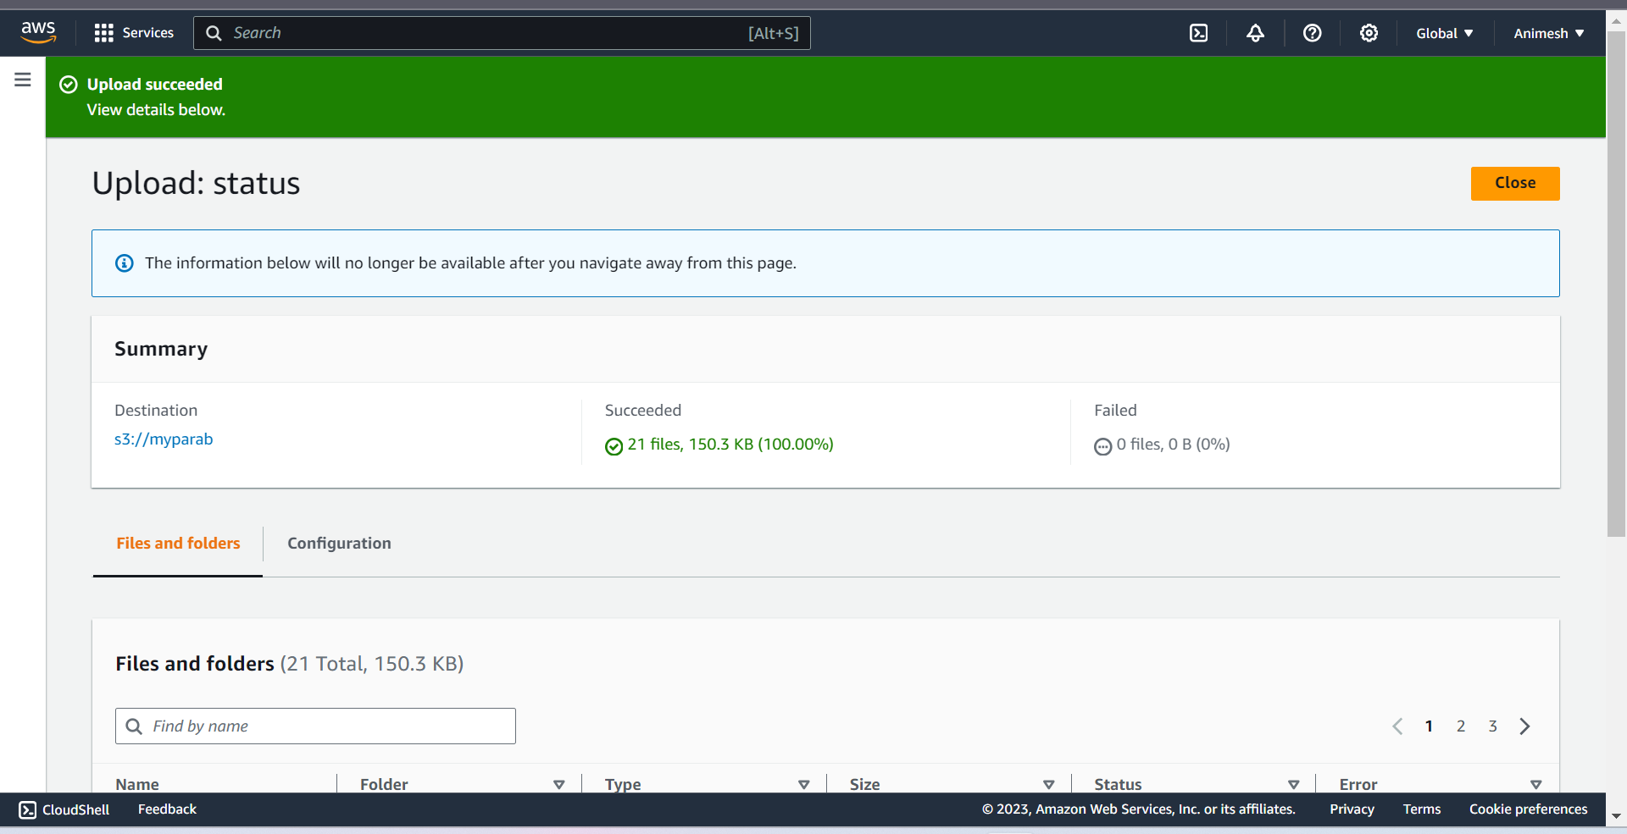

**5.Go to the index.html folder and copy the Object URL. Copy this URL to another web page, it will show error.**

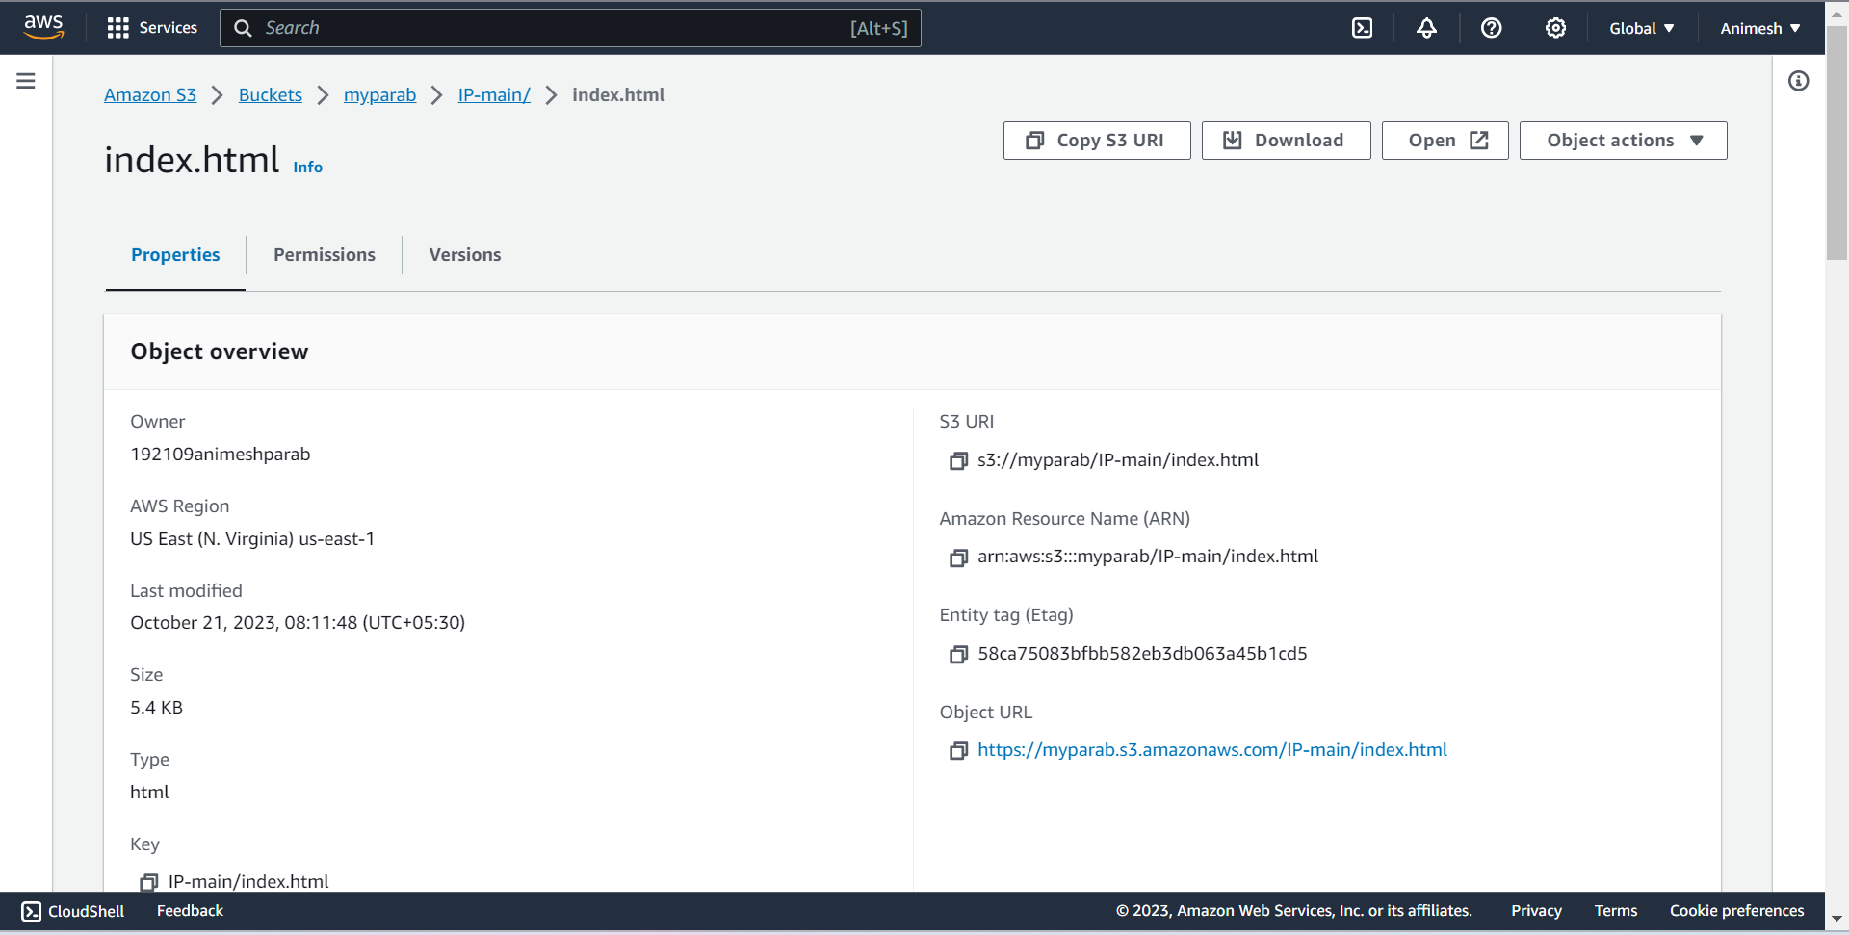

1. **Now we need to enable permissions. Click on Premission tab.**

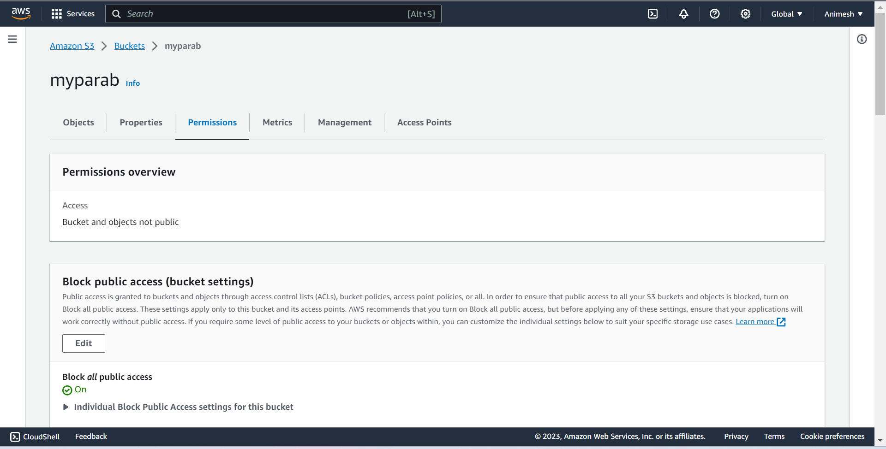

1. **Change the public access permission.**

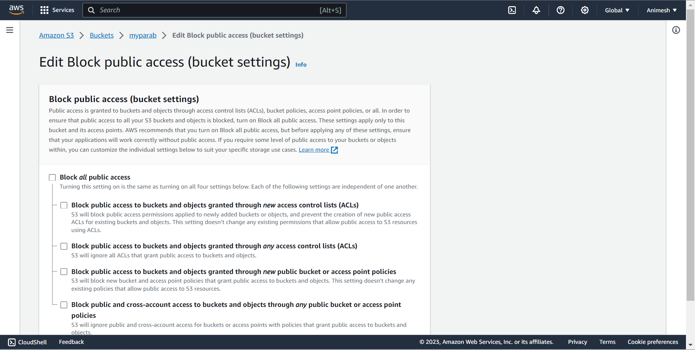

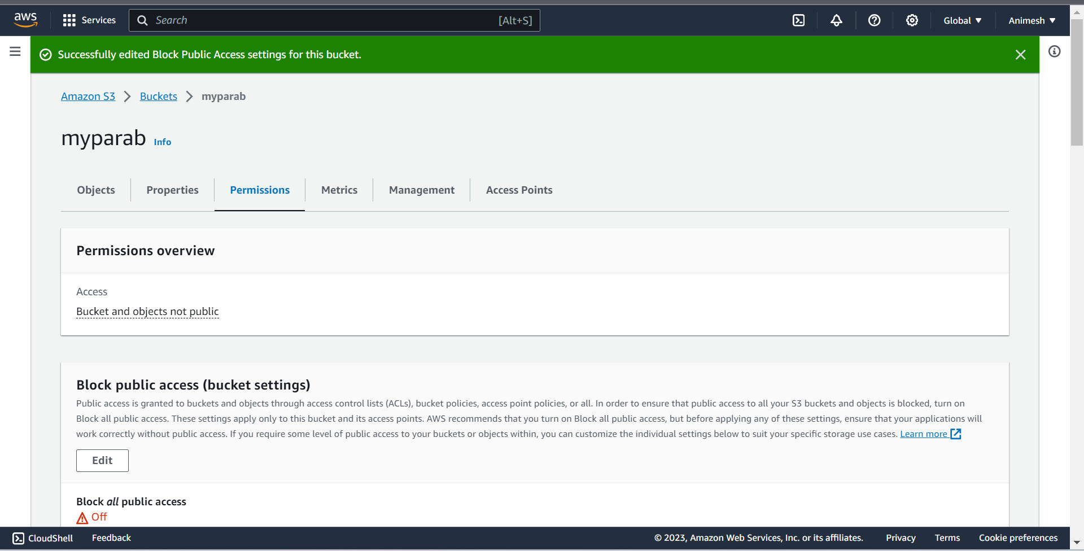

1. **. Go to the Object Ownership and Enable the ACLs**

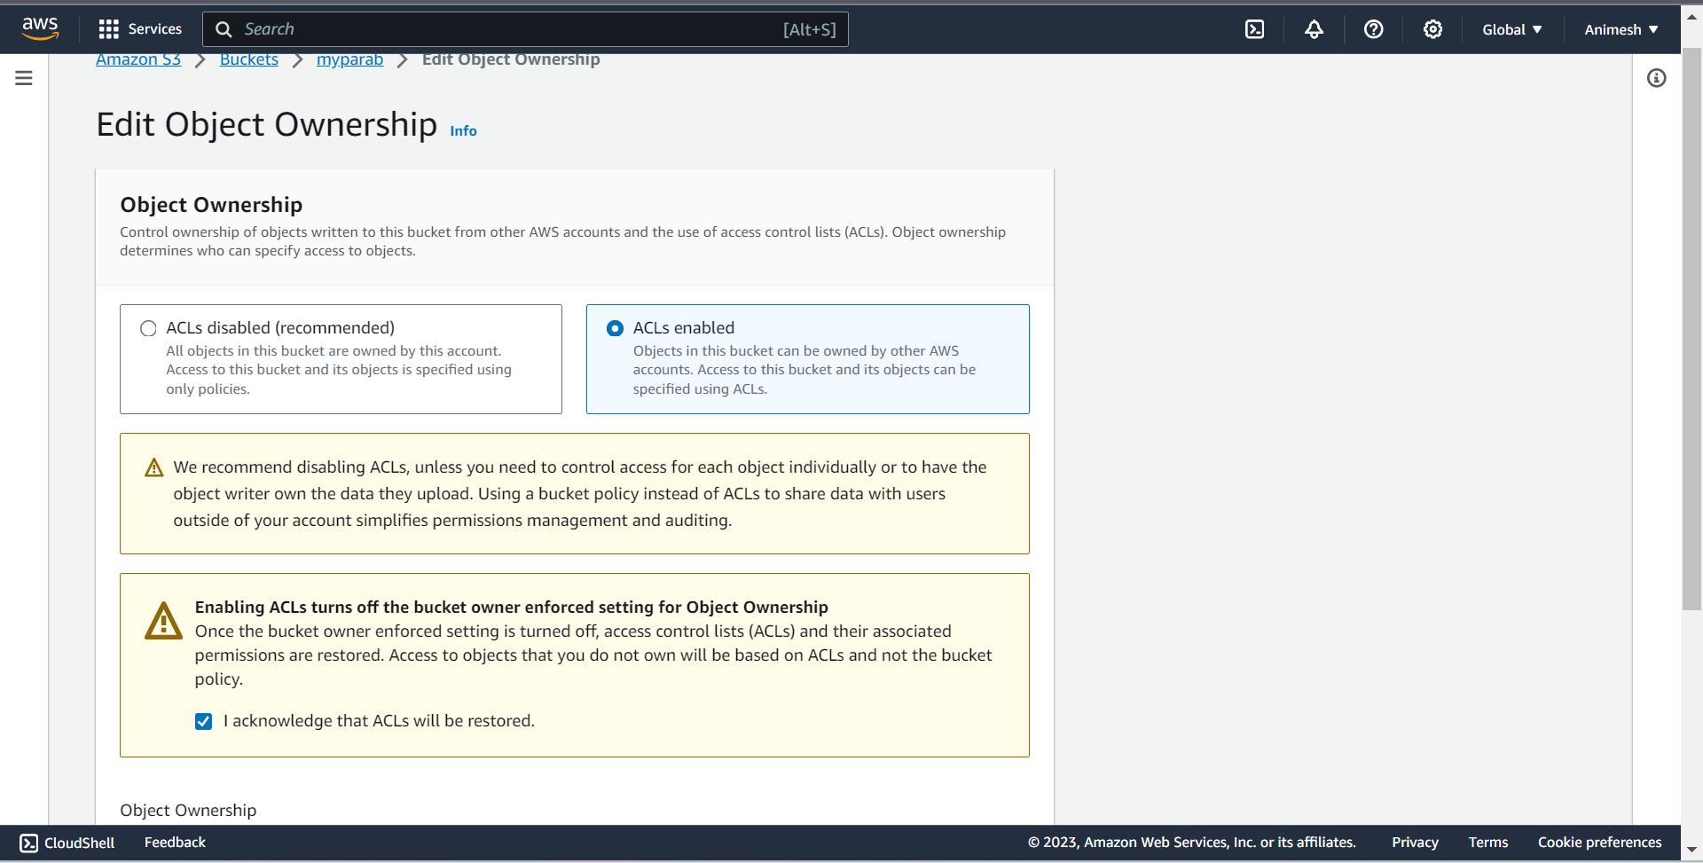

1. **Finally select all the files and folders and click on Actions and click on 'Make public using ACL'.**

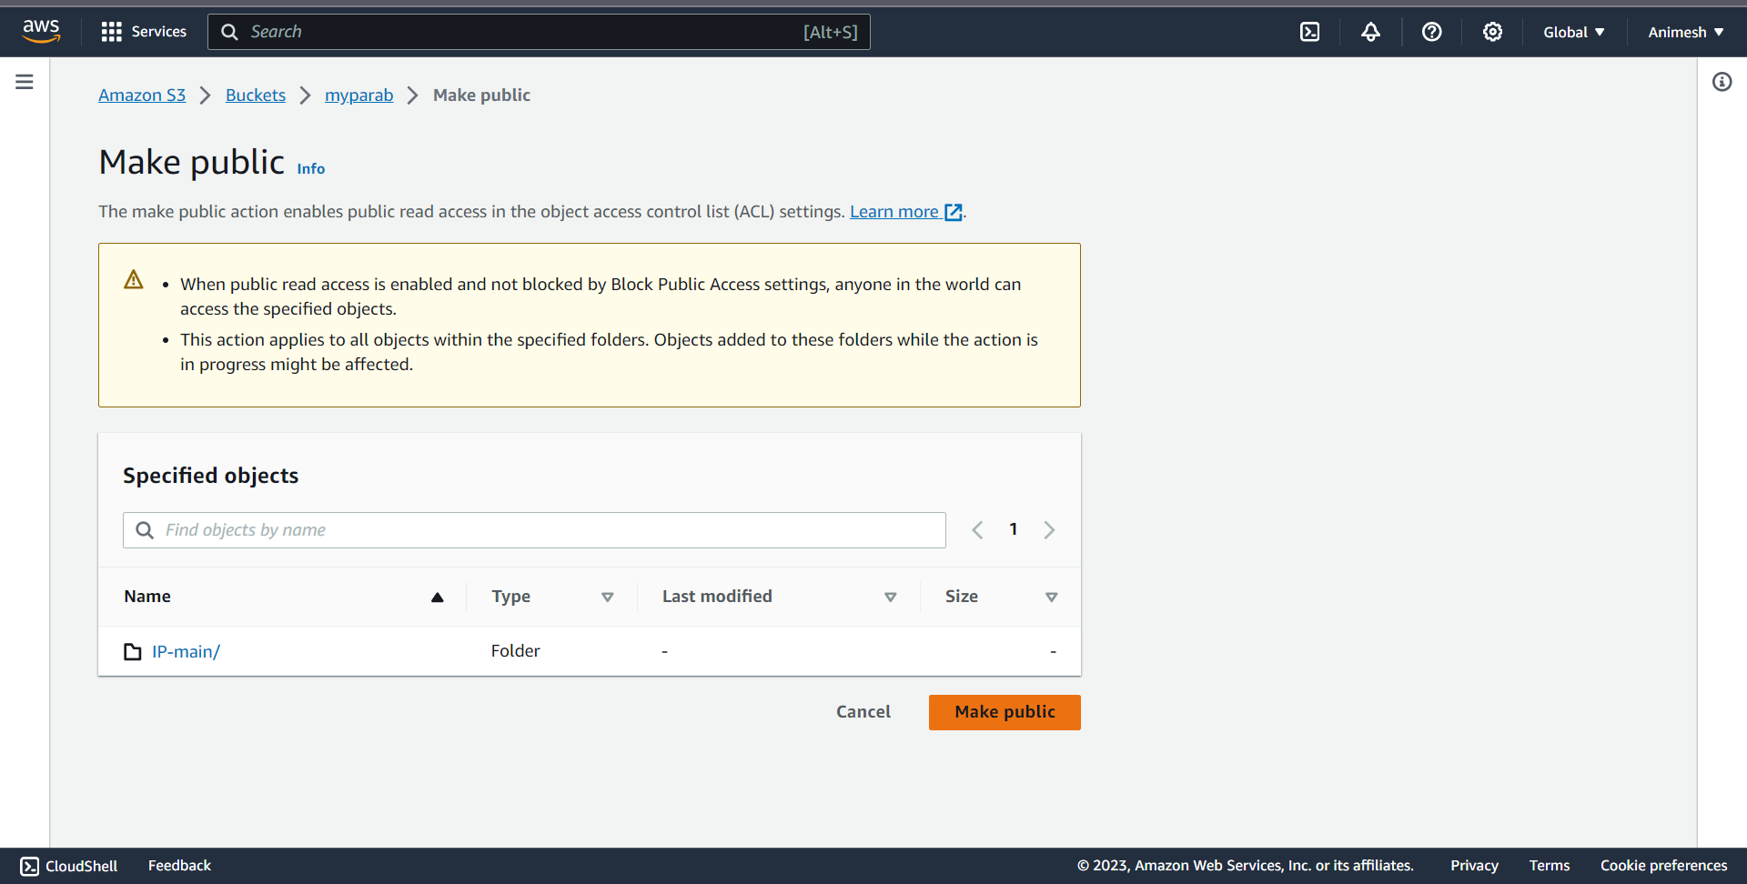

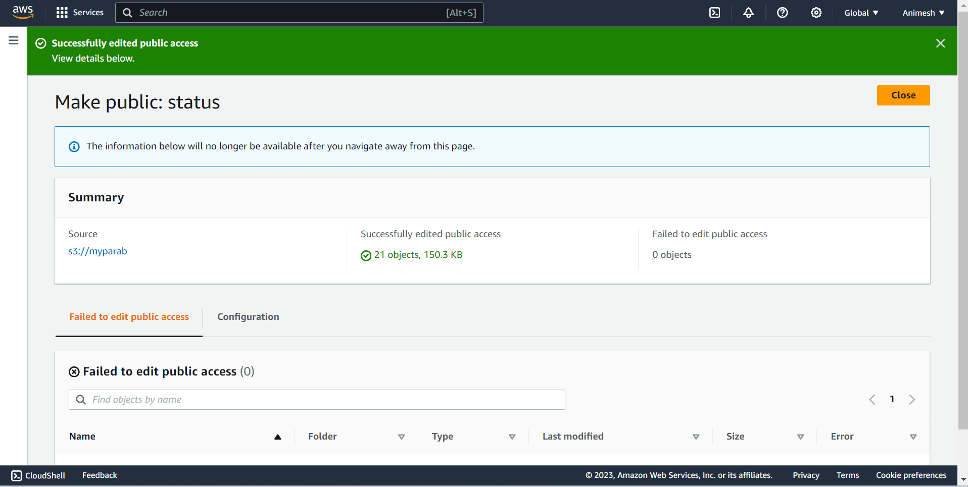

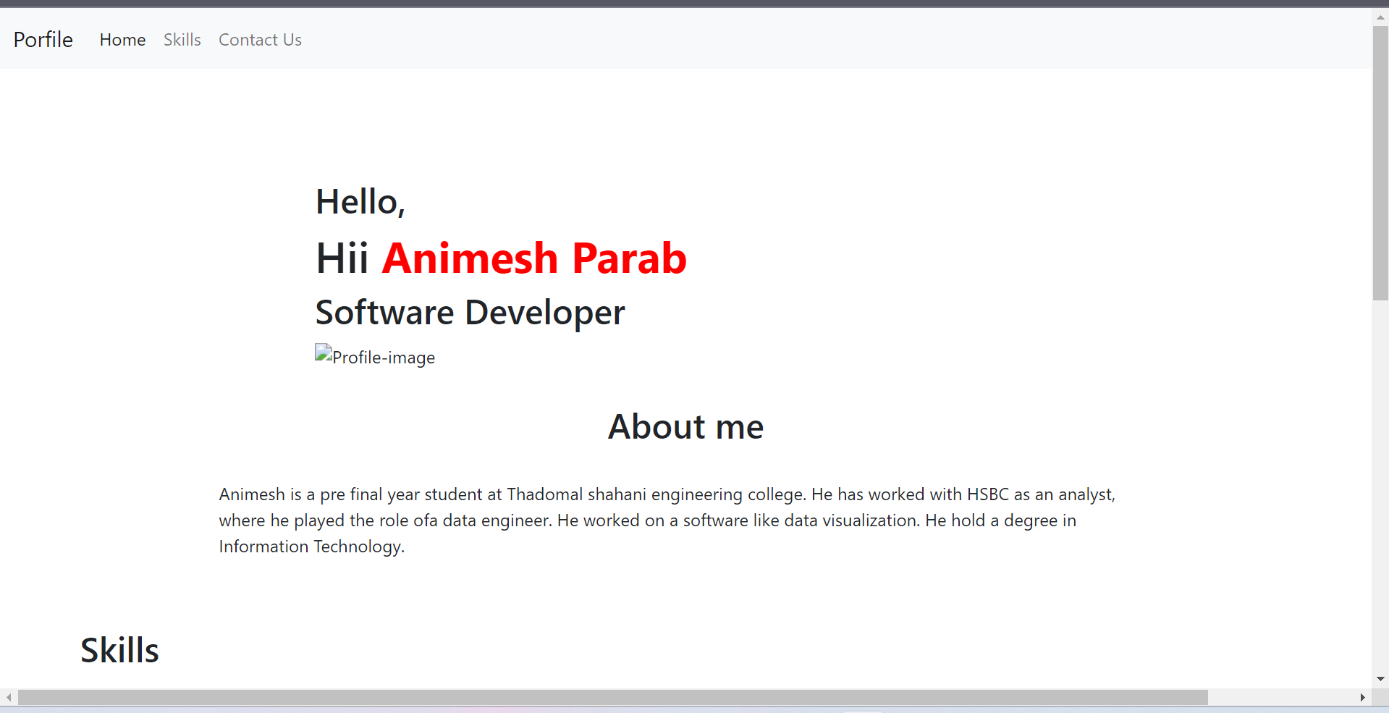

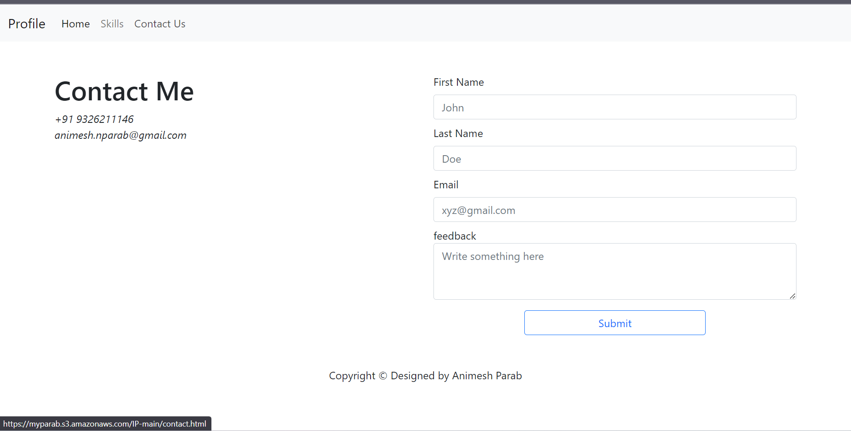

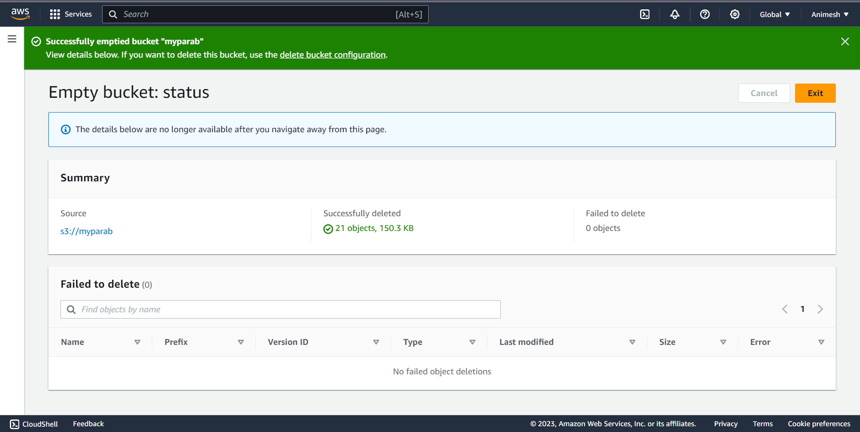

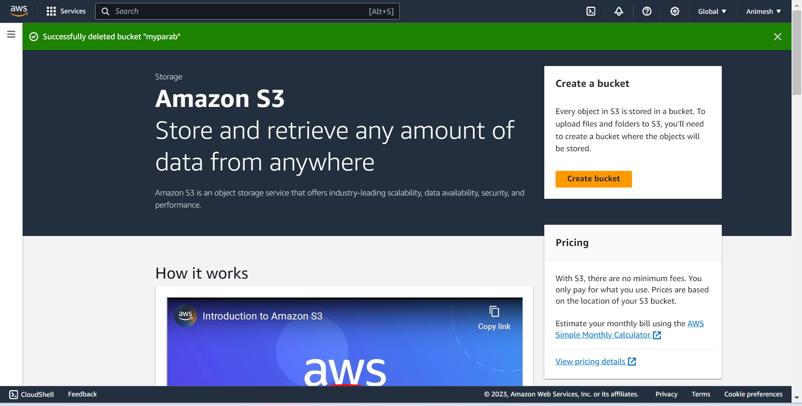

**CONCLUSION:-**

In this assignment, we learnt how to build our application using AWS Code Build and Deploy on S3 using AWS Code Pipeline.